Zebra XSLATE R12 Rugged Tablet
The tablet that transforms to match your work style. Rugged redefined.
Think you need a desktop, laptop, and rugged tablet to excel at the tasks you complete in the office, in-vehicle, and in the field? You don’t...anymore. You just need the highly mobile, extremely flexible and always resilient XSLATE® R12 tablet PC. The transformational tablet device gives you all the high performance features and complete computing functions you need in a single platform.

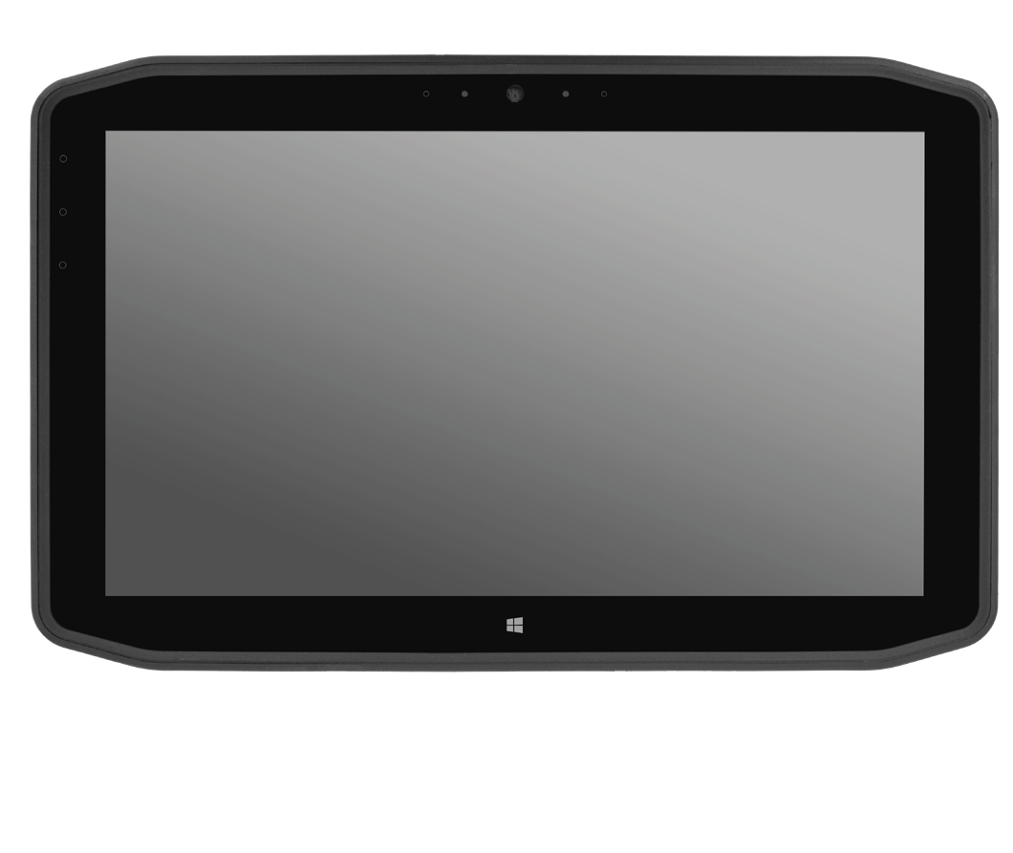The XSLATE R12 is a next-generation tablet designed to be the only computer you’ll need. It is one of the fastest rugged tablets on the market today and features powerful 2-in-1 capabilities with a
Always the right form. More than enough flexibility

Appeal to the workforce
This transformational rugged tablet PC will go with the flow – and manage a task list as diverse as yours:

- Quality Assurance
- Inspections
- Inventory Management
- Safety Audits and Compliance Reporting
- Asset Monitoring and Control
- Maintenance and Repair Scheduling and Completion
- Claims Processing
- Engineering/Construction Project Management
- Incident Reporting
- Dispatch and Routing (GPS)
- Mapping/GIS Asset Location
- Investigations
- Situational Awareness
- Evidence Documentation
- Ticketing & eCitations
- Electronic Patient Care Reporting (ePCR)/Electronic Health Records (EHR)
- Emergency Response Planning and Management
magnetically-attached Companion Keyboard that’s always on standby and never in the way. You’ll also have the clarity of the industry’s brightest 12.5” display, and easy-to-use touch, pen, voice, and camera
inputs.
With all of these options, you can’t go wrong
The XSLATE R12 offers more high performance feature options than any tablet PC in its class. You can pair powerful 7th generation Intel® processors with your preferred Windows® Professional OS. Attach an RJ45 + RS232 True Serial port dongle. Or add the SlateMate™ module to automatically gain a barcode reader and HF RFID reader for easy point of service data acquisition. If you’re a multi-tasker who needs consistency – and options – you’ll get everything you need in one rugged tablet.

Rugged redefined. Mobility without compromise.
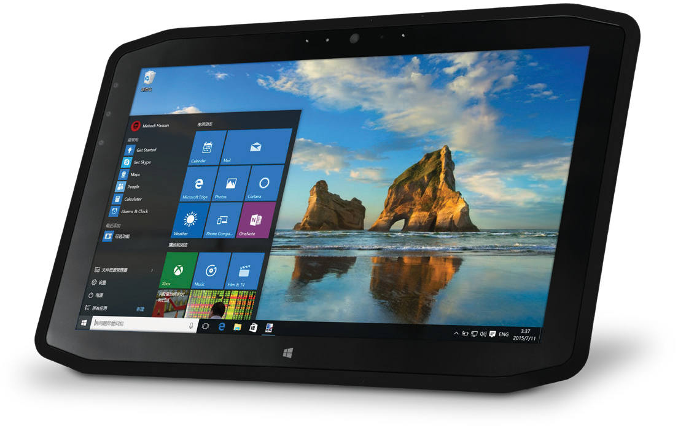
This rugged tablet is built to keep your TCO low and ROI high, especially as mobility demands grow. It’s ready for the field and front office, patrol car and factory, present and future. Expandable SSD, storage, and memory components keep pace with rising data demands. This level of connectivity ensures you never lose touch with workers, legacy equipment, and evolving business systems.
You’ll have complete situational awareness in real-time and customer service advantages at all times.

The tablet that does it all
Do you need a single mobile computer platform that matches any one of your workers’ tech styles, and every one of your workflow requirements? No problem. The XSLATE R12 is prepared to multi- task in demanding work environments. With its highly responsive pen and touch input capabilities, magnetically-attached Companion Keyboard, adaptable form factor, and customised mounting options, this powerful rugged tablet gives all of your workers the flexibility to quickly and comfortably complete any task at hand – even when it looks like a notebook or desktop.

FROM THE FIELD TO THE VEHICLE TO THE OFFICE

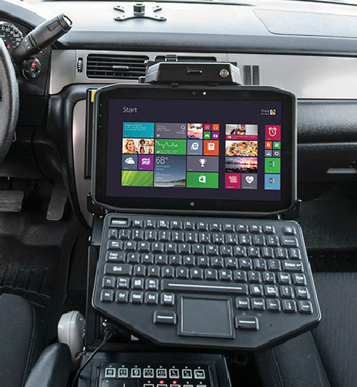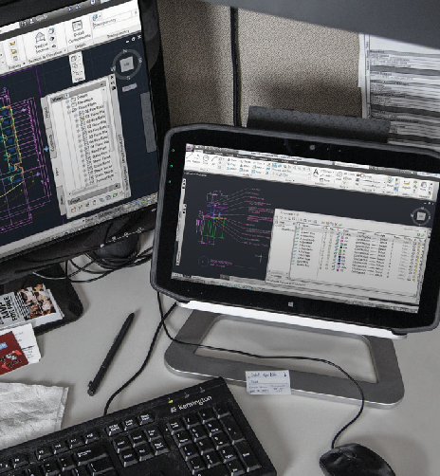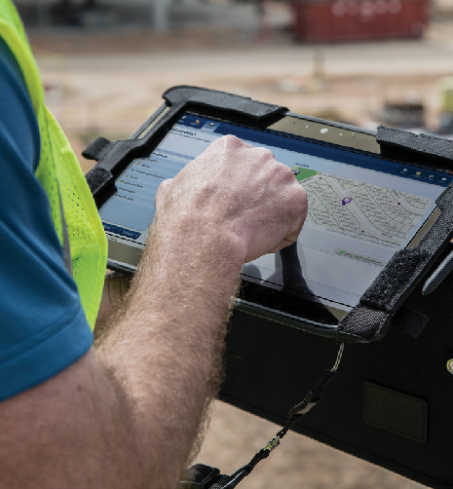 Choose Accessories to Maximise Your Mobility Investment

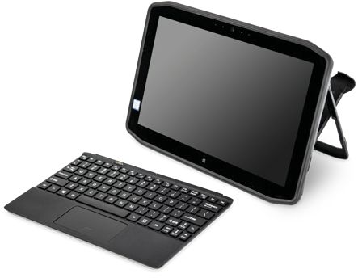
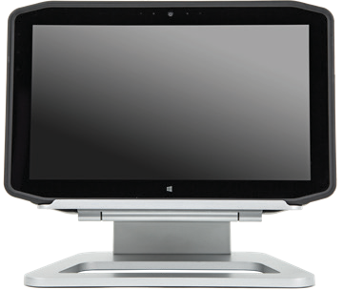
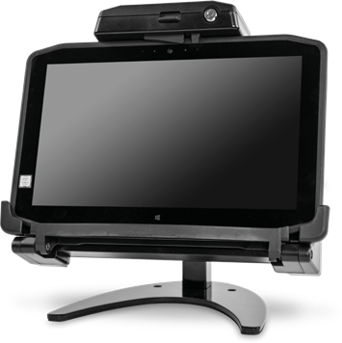
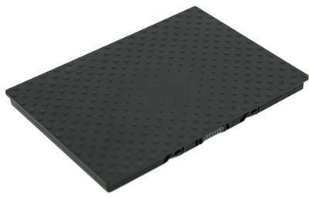

Companion Keyboard Docking Station Secure Mobile Dock
(for vehicle or desktop)
Additional Battery

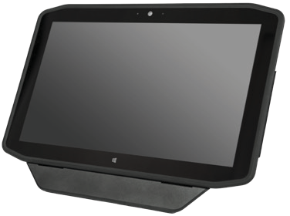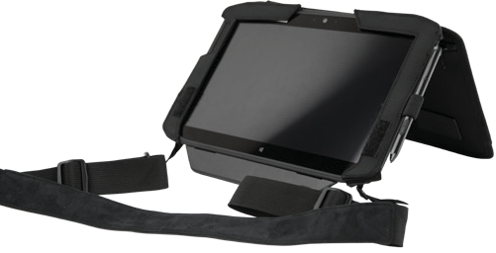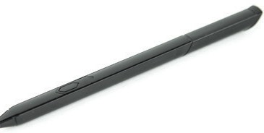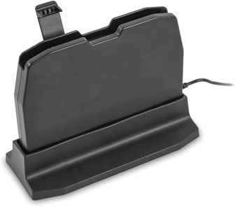

SlateMate Data Acquistion Mobile (Barcode Reader and High Frequency RFID)

Work Anywhere Kit
(case, shoulder strap, carry handle, screen cover)
Additional Digitizer Pen Battery Charger

XSLATE R12 Tablet Specifications Chart

DURABILITY
Drop Test MIL-STD-810G
- 4’ drop tested onto plywood over concrete

Integrated Communications
- Intel® Dual Band Wireless-AC 8260 Wi-Fi plus Bluetooth® 4.2
- Optional Internal Wireless (1 expansion slot)
- Sierra Wireless EM7455 (NA and EU)

Hazardous Environment
Class 1 Division 2 for hazardous locations1
4G LTE with GNSS (GPS + GLONASS + Beidou)
or
- Sierra Wireless EM7430 (APAC)

Ingress IP54
Internal Magnesium-alloy internal frame
External Rubberised enclosure

SYSTEM FEATURES
Operating System • Windows® 10 Pro 64-bit
  - Windows® 8.1 Pro 64-bit*†
  - Windows® 7 Professional 64-bit*†
*available thru Windows 10 downgrade
† available on i5-6200U only
Processor • Intel® Core™ i7 vPro - 7600U
- 2.8 GHz with turbo frequency to 3.9 GHz, 4 MB SmartCache, 2 cores (4 threads)
  - Intel® Core™ i7-7500U
    - 2.7 GHz with turbo frequency to 3.5 GHz, 4 MB SmartCache, 2 cores (4 threads)
  - Intel® Core™ i5-6200U
4G LTE with GNSS (GPS + GLONASS + Beidou)
or
- Navisys Technology (u-blox)
GPS with SBAS (WAAS, EGNOS and MSAS)
  - Pass-Through antenna for WWAN, WLAN and GPS

Ports • Docking connector
  - USB 3.0 port
  - HDMI port
  - 3.5 mm audio output (stereo out, mono in)
  - Micro-SIM Card Slot (3FF)
  - Micro-SDHC port

Integrated Options • Optional 1D/2D Barcode Reader via SlateMate®
  - Optional 13.56 MHz HF RFID with read/write capability via SlateMate®
  - Optional RS232 True Serial Port via Dongle
  - Optional RJ45 Gigabit Ethernet Port via Dongle
  - Optional Integrated CAC/Smart Card Reader

    - 2.3 GHz with turbo frequency to 2.8 GHz,w 3 MB SmartCache, 2 cores (4 threads)
  - Intel® Celeron® 3865U
- 1.8 GHz, 2 MB SmartCache, 2 cores (4 threads)

Memory • 4GB (Celeron® 3865U only)
  - 8GB

Battery Life & Power
- Battery operation
  - Standard battery: up to 9 hours1
- Battery charge time
  - Standard battery: 2.75 hours with system off2
- Standard bridge battery (1 minute swap time)
  - Hot swap battery feature comes standard
- Input Voltage: 19V with AC Adapter

Storage Options • 64 GB SSD**
- 128 GB SSD
- 256 GB SSD
(M.2 SATA only) (M.2 SATA or PCIe) (M.2 SATA or PCIe)

Dimensions / Weight

- 12.93” x 8.17” x .75”
w(328.5 mm x 207.5 mm x 19 mm)
- 2.95 lbs (1.34 kg)3

- 512 GB SSD (M.2 SATA or PCIe)

- 1 TB SSD***
(M.2 PCIe only)
Security • Integrated Fingerprint Reader
  - Trusted Platform Module (TPM) 2.0

** 64 GB M.2 SATA SSD only available with 3865U
- Optional CAC / SmartCard reader

processor configuration

*** PCIe drives only available with 7500U & 7600U processor configurations

Display • 12.5” Wide Viewing Angle Display
- Full-HD Resolution (1920 x 1080)
- 1000 Nit Display Brightness
- Anti-Smudge & Anti-Reflective View Anywhere® Display
- Corning® Gorilla® Glass 3
- Capacitive 10-Point Touch
- Wacom Digital Pen Input
- Standard user replaceable anti-glare screen

Graphics • Intel HD Graphics 620 for i7-7500U, i7-7600U
- Intel HD Graphics 610 for Celeron® 3865U
- Intel HD Graphics 520 for i5-6200U
Camera • 8 MP rear camera
- 2 MP front camera

** 64 GB M.2 SATA SSD only available with 3865U processor configuration
*** PCIe drives only available with 7500U & 7600U processor configurations
Audio • Intel® High Definition Audio
- Realtek® HD Codec
- RealTek noise cancellation
- Multi-directional array microphone
- 3 microphones (2 front facing array mic’s and 1 rear facing mic)
- 2 Integrated speakers

Status Indicators • Power/Battery Status
- Camera Active
- SSD Activity

Continued on page 4

XSLATE R12 Tablet Specifications (continued)

SOFTWARE

Software • Know Your Tablet (Windows 10, 8.1, 7)
  - Pen and Touch Enabled BIOS Setup
  - xCapture Pro™ Camera App
  - Xplore Dashboard (Windows 7)
  - Xplore Tablet Center (Windows 10, 8.1)
  - RFID Sample Reader (SlateMate™)
  - Barcode Reader (SlateMate™)

WARRANTY
REGULATORY

Product Safety • UL/CSA 60950-1, 2nd Ed.
  - IEC/EN 60950-1
  - AS/NZS 60950-1, 2nd ED.
  - LVD Directive 2014/35/EU
  - NOM 019
  - ANSI/ISA 12.12.01-2013 (Hazardous Location)
SAR • FCC OET 65 Supplement C
  - CAN/CSA RSS-102 Issue 5, Safety Code 6
  - EN 62311, EN 62209-2

Warranty Information
- 3 year standard coverage included
- Extended Warranty & xDefend Programs available.

EMC • FCC Part 15 B, Class B
- CAN/CSA ICES-003, Class B
- EN55032, Class B
- EN 301-489-1
- EN 301-489-17
- EN 301-489-24

TESTING AND STANDARDS

Standards • ACPI 5.0 compliant
- UEFI BIOS
- Certified for Microsoft Windows 10 Client family version 1607, x64
- Microsoft Azure Certified for IoT

IEC Ingress Testing • IEC (60529) Ingress Tested to an IP54 Standard

Environmental • Tested to MIL-STD-810G Standards
- Operating Temperature: -20 °C to 60 °C / -4 °F to 140 °F
- EN 61000-3-2
- EN 61000-3-3
Environment • California Proposition 65
- Battery Charging Systems
- RoHS 2 Directive 2011/65/EU
- WEEE Directive 2012/19/EU
- Battery Waste Directive 2013/56/EU
- EN 62623:2013 ( ErP Lot 3 / Lot 26)
- NMX -1-122-NYCE-2006 (Mexico Energy Consumption)
- Energy Star Compliant

- Storage Temperature: -30 °C to 70 °C / -22 °F to 158 °F
- Transit Drop - Operating: 4’ (1.22 M) Drop Direct to Plywood over Concrete while System is Operating, 26 Drops
- Vibration: Minimum Integrity Non-operating, US Highway Truck and Composite Wheel Operating
- Shock: 20G Operating, 40G non-operating
- Humidity: 23 °C to 60 °C / 73 °F to 140 °F, 95%
NonCondensing, 10 Days
- Water Proofness: Fig 506.5, 140L/hr, per sq/m, 15 Minutes
- Blowing Sand: 20M/S, rate 1.1g/m3 (+/-.3g) at High Temperature of 60 °C
- Blowing Dust: Velocity 8.9M/s Dust Concentration
3.9 g/m3 at High Temperature of 60 °C
- Temperature Shock: -30 °C to 70 °C / -22 °F to 158
°F within 5 Minutes
- Contamination by Fluids: 50/50 Solution of Water and Bleach, 50/50 Solution of Water and Hydrogen Peroxide, Diesel Fuel, Mineral Based Oil, Lysol Disinfectant, Denatured Alcohol, Isopropyl Alcohol
- Altitude: 40,000 Ft (12,192 M) Operating, 50,000 ft (15,240m) Non Operating

1 Battery performance will vary by system configuration. Battery life and recharge estimates will vary based on system settings, applications, optional features, environmental conditions, battery conditioning and user preferences. MobileMark 2014 performance testing on Intel Core i7

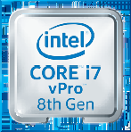
2 Approximate charging time. Validated charging from 5% to 90% with system on or system off.

3 Weight represents approximate system weight measured with a 45WHr battery. Actual system weight may vary depending on component and manufacturing variability.

4 GNSS not available when external monitor is in use.

Zebra acquired Xplore Technologies and all its products in 2018.

NA and Corporate Headquarters
+1 800 423 0442
inquiry4@zebra.com Asia-Pacific Headquarters
+65 6858 0722
contact.apac@zebra.com
EMEA Headquarters
zebra.com/locations contact.emea@zebra.com Latin America

©2018 ZIH Corp and/or its affiliates. All rights reserved. ZEBRA and the stylised Zebra head are trademarks of ZIH Corp, registered in many jurisdictions worldwide. All other trademarks are the property of their respective owners. Part number: R12-XSLATE-A4-EN 10/19/2018

